Java Center of excellence
Using the Presentation Sample

April 11, 2019
Describes how to setup, configure, and use the Presentation Sample functionality which is part of the Ford Java Frameworks (FJF).

For more information or feedback, contact the Java Center of Excellence

*For current version, see: https://www.tc2.ford.com/ts/JCOE/Lists/Frameworks/Summary.aspx
Revision History
This page documents general changes/modifications made to the document.
Version | Update Date | Change Description | Author
1.0 | 05/29/2013 | Initial Release | SYADAV3
JAVA CENTER OF EXCELLENCE
Table of Contents
1 Purpose 4
2 Audience 4
3 Introduction 4
4 Getting Started 5
4.1 Required Files 5
5 Installing and running the Presentation Sample Project in RSA 6

Purpose
The purpose of this document is to provide instructions on how to use the Presentation Sample in J2EE application. This document explains where to get the Presentation Sample, how to configure it.

(Note - JAB application uses Presentation Framework and it can be used as sample project.)

Audience
The target audience of this document is all developers, architects, and analysts interested in using the Presentation Framework.

Introduction
Some of the sample functionalities that can be performed via the Presentation Sample are listed below.

- Select From List Custom Tags Examples
- Menu Custom Tags and Breadcrumb Custom Tags Examples
- Calendar Date Selector Custom Tags Examples
- File Upload

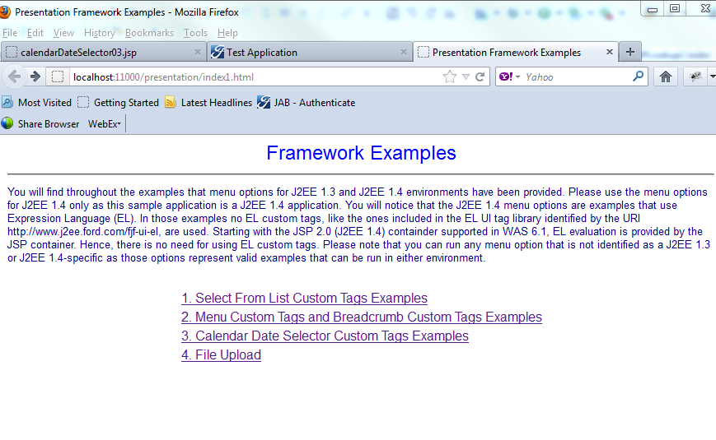

Getting Started

Required Files
The Presentation Sample can be obtained by downloading the presentation -vx.y.zip file from the J2EE Website
https://www.tc2.ford.com/ts/JCOE/Lists/Frameworks/Summary.aspx
This zip file contains a set of Java Archives and supporting files that are required for Presentation Framework and PresentationSample.

Installing and running the Presentation Sample Project in RSA
There are few steps that you will need to do in order to install the Presentation Sample project in RSA
They are:

- Get the Presentation framework (presentation -vx.y.zip) from the JCOE Web Site.

https://www.tc2.ford.com/ts/JCOE/Lists/Frameworks/Summary.aspx
- Unzip the presentation -vx.y.zip into a temporary directory.

- Create new RSA workspace for Presentation Sample project.

- Import Preferences file. (File → Import → General → Preferences)

- Import PresentationProperties, PresentationSampleEAR, PresentationSampleWeb

(File → Import → General →Existing Project into Workspace → browse to temporary directory created in step 2 → Select PresentationProperties, PresentationSampleEAR, PresentationSampleWeb )
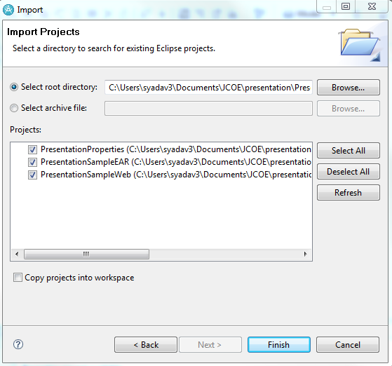

- Add PresentationSampleServe and configure it.

(Please see Desktop Server Configurator to install, configure and use the tooling required to
Configure a WebSphere server for desktop testing)

- Following is the URL for testing application on local host.

http://localhost:11000/presentation/index1.html

